**Java 1: Test #1**

Tuesday, October 3, 2017

**[10] Question 1)** **Find the syntax errors in the following program. There are 15 in total; only 10 are required for full marks. Please use the red circle to identify the errors.**

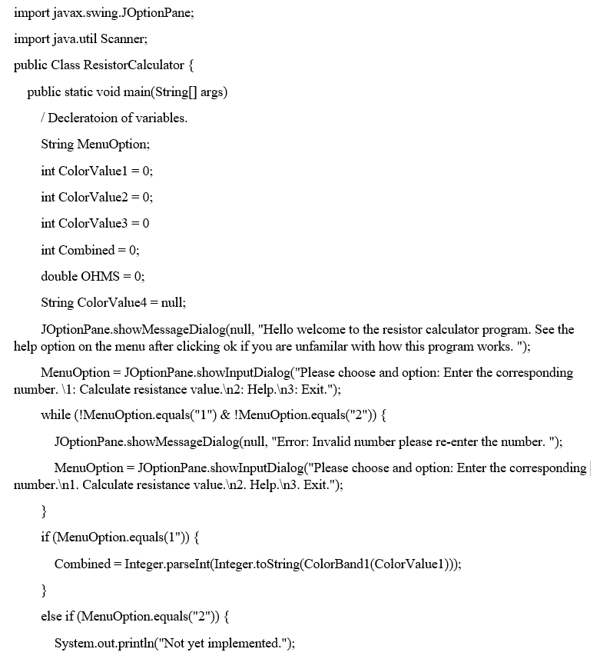

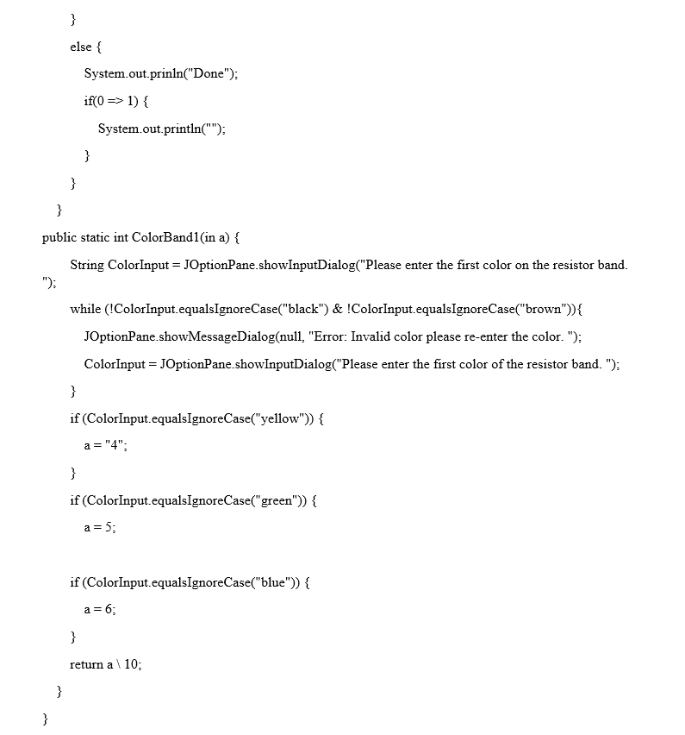

**Please answer the following questions, if you have any difficulties or concerns please let me know. If you are in doubt with any of the questions, writing out the pseudo code beforehand may help. I will take this in consideration when marking.**

**[10] Question 2)** [**Loops/Selection**]: **Write a complete program where the user can enter 100 decimal numbers. The program will then perform the following operations:**

1. **Display the smallest number.**
2. **Display the largest number.**
3. **Display the average of the numbers.**

**[10] Question 3) [Code Segment Only]: Write a do-while loop that will display the numbers divisible by 3 and 5 in a range of numbers represented by numLow and numHigh. Assume numLow and numHigh are already set correctly in the program.**

**[10] Question 4) [Method]: Write a complete program that will allow the user to enter in values for integer variables x, y, z. Once the values are entered, a method should be used to calculate the following algebraic expression. The result should be stored in a variable named result, rounded, and then displayed to the user. Use Math.round(number); Please display the result in the main method. The method you write should return the result.**

**42 * x / 70 + y – z * 420 * z / Math.PI();**

**[10] Question 5) [Loops/Methods/Selection]: Write a complete program that will allow the user to enter a single String. Next, write a method that will display the string in reverse, a method that will display the first and last character of the string, and one final method that will convert each character of the string to its decimal representation then sum up each value, then display the result to the user.**

**[Hint]: String temp = “test”; temp.chartAt(index); This example will help you with the question. Also remember to get the decimal representation of a string we must cast each individual character to a integer.**